Description for the Activity Diagram

There are three swim lane in total to show different action in different characters, they are Customer, Payment System and Secretary.

First, we start from the Customer who have the idea to pay the sponsorship and become a group member in the sports club.

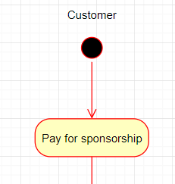

It means that the Customer have to show his personal data to the secretary who works for the club in order to get authorized and register.



Different situation will cause different consequences. If the customer show an invalid ID, the registration will all the way down to Terminate Sponsorship Payment.

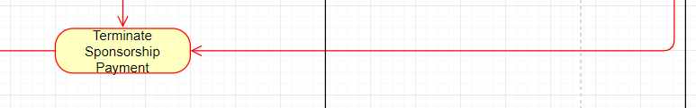

If it’s valid, the payment process will continue and ask for the amount of money that the customer want to pay for sponsorship.

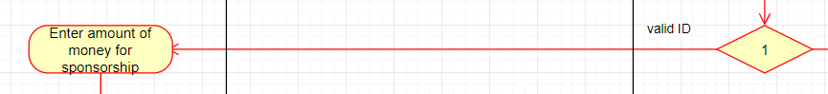

There are three ways to pay depend on the Customer. If he chooses to pay in instalments, the payment system will lead him directly to the condition that the Customer had already paid the sponsorship successfully.

But if the Customer choose to pay in full or pay in credit, the Secretary will check the account balance in order to make sure everything goes perfect. If the balance is less than the amount that the Customer is going to pay for, the Payment System will all the way down to show remaining balance step and terminate payment. If the balance is more than or equal to the amount, the Secretary will assume the payment succeed and choose to log receipt, verify sponsorship and record payment.

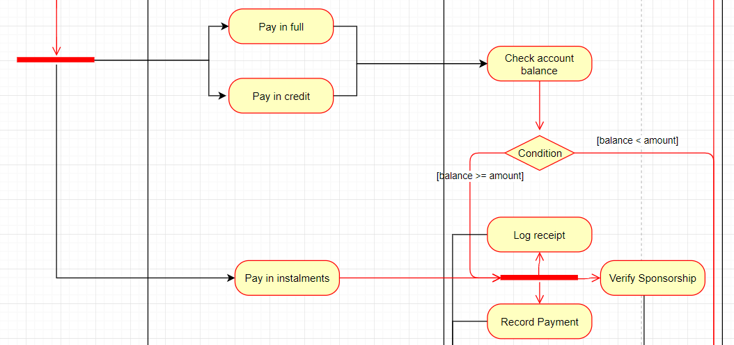

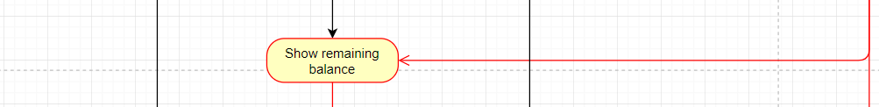

The Secretary will then upload the payment record to Payment System and The Customer becomes a sports club member officially and have the authority to join a sports event.

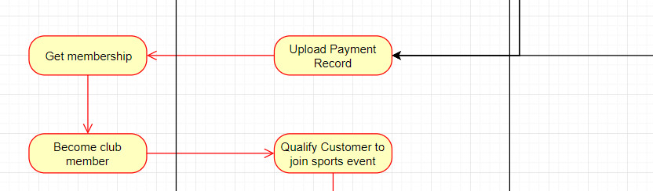

The Payment System then show the remaining balance as usual and terminate the payment which leads to the end.

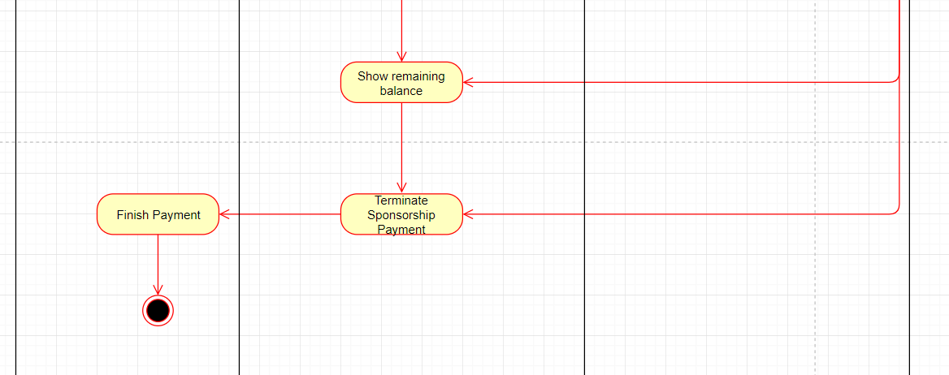

Use Case Textual Descriptions:

1. Name : Sponsorship Payment System
2. Participating Actor : Secretary , Customer , Payment System
3. Entity Condition :

*Customer* has a name

*Customer* has a gender

*Customer* stands in front of the *Secretary*

*Customer* has sufficient money to purchase the club sponsorship

*Customer* has a phone number to stay contact

*Customer* has an address to allow the *Payment System* send messages and gifts

1. Exit Condition:

Customer finish paying the fund either by using pay in credit or pay in instalment or pay in debit and then got a receipt from the *Payment System* after logging the receipt.

1. Normal Scenario:
2. *Customer* selects the way to pay the sponsorship(credit or debit or instalment)
3. *Receipt* displays the amount of fees and personal bank information of the *Customer.*
4. The *Customer* pays the money , at least the amount of fees that listed in the receipt and pay it before the due day
5. *Payment System* returns the receipt
6. *Payment System* verifies the customer’s sponsorship
7. Error Scenario:
8. *Customer* change his mind and decided to sponsor a less amount of fees
9. *Customer* gave the wrong type of the money
10. *Customer* don’t have enough funds to sponsor

-Delay the sponsorship registration and provide explanation.